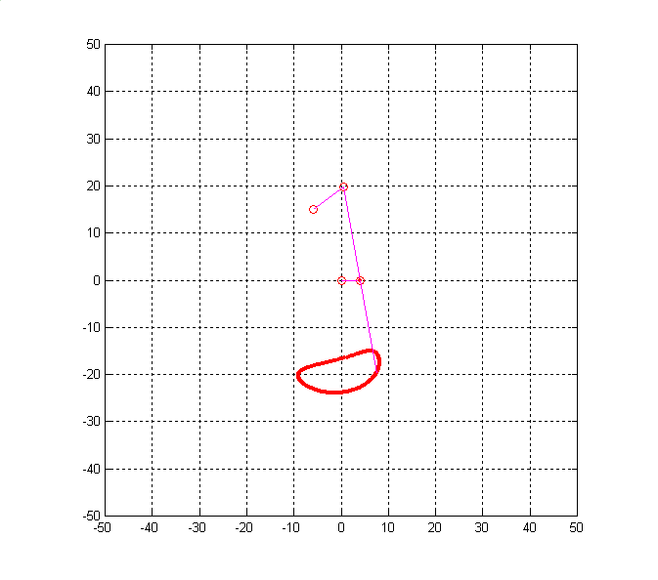
dx=-6;
dy=15;
r2=4;
r3=20;
r4=8;
r5=20;

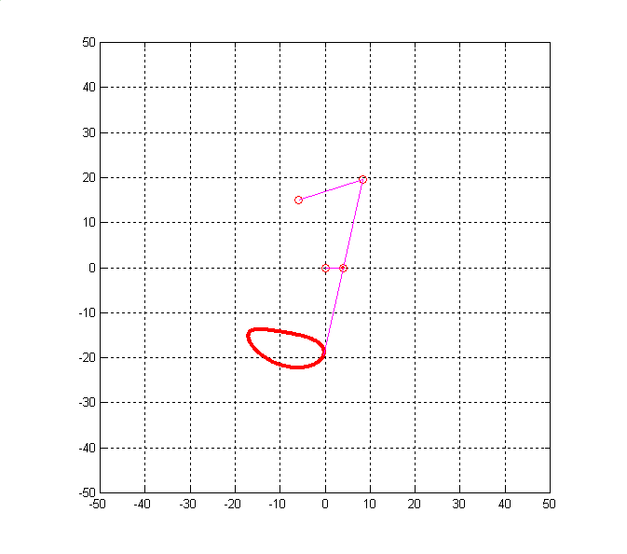

dx=-6;
dy=15;
r2=4;
r3=20;
r4=15;
r5=20;

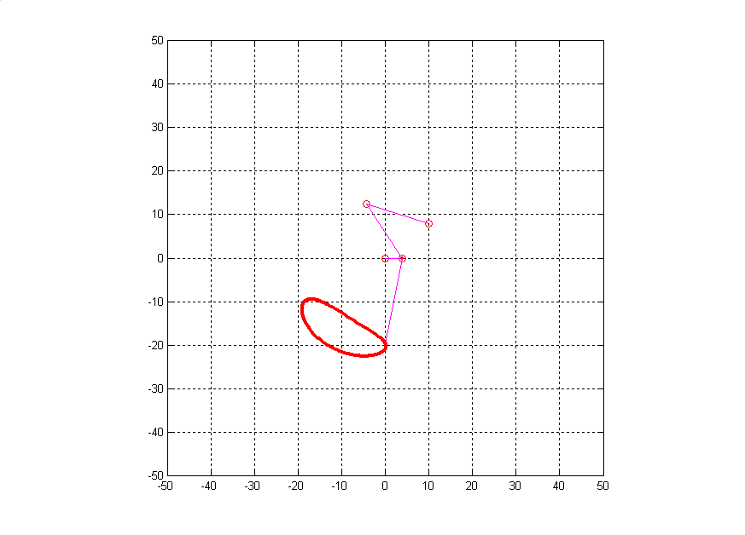

dx=10;
dy=8;
r1=abs(sqrt(dx^2+dy^2));
r2=4;
r3=15;
r4=15;
r5=20;
teta1=atan2(dy,dx);

