A Critical Review of MEMS Gyroscopes Technology and Commercialization Status

Steven Nasiri, 408-741-5443, snasiri@invensense.com
19500 Via Real Dr. Saratoga, Ca 95070

Abstract

Gyroscopes are expected to become the next “killer” application for the MEMS industry in the coming years. A multitude of applications already have been developed for consumer and automotive markets. Some of the more well known automotive applications such as vehicle stability control, navigation assist, roll over detection are only used in high-end cars, where cost is not a major factor. Examples of consumer applications are 3D input devices, robotics, platform stability, camcorder stabilization, virtual reality, and more. Primarily due to cost and the size most of these applications have not reached any significant volume. This paper provides a top-level review of various vibrating mass gyroscopes and examines the technology and packaging methodology for top four commercially available gyroscopes companies. Advancement in MEMS technology, fueled by the optical bubble, such as, wafer-scale-integration, and wafer-scale-packaging will be reviewed. New opportunities for design and development of the next generation of low-cost and high-performance gyroscopes based on the latest MEMS technologies are discussed.

Introduction

Micromachined inertial sensors, consisting of accelerometers and gyroscopes, are one of the most important types of silicon-based sensors. Microaccelerometers alone have the second largest sales volume after pressure sensors. It is believed that gyroscopes will soon be mass-produced at similar volumes once manufacturers are able to meet a $10 price target. Applications for gyroscopes are very broad. Some example for these applications are; automotive; vehicle stability control, rollover detection, navigation, load leveling/suspension control, event recording, collision avoidance; consumers, computer input devices, handheld computing devices, game controllers, virtual reality gear, sports equipment, camcorders, robots; industrial., navigation of autonomous (robotic) guided vehicles, motion control of hydraulic equipment or robots, platform stabilization of heavy machinery, human transporters, yaw rate control of wind-power plants; aerospace/military; platform stabilization of avionics, stabilization of pointing systems for antennas, unmanned air vehicles, or land vehicles, inertial measurement units for inertial navigation, and many more.

This paper presents a review of silicon MEMS gyroscopes (rate sensors), their production status, and challenges towards fabrication of the next generation of lowcost gyroscopes. Following a brief introduction to gyroscope operating principles and performance specifications, the present status in the commercialization of micromachined rate sensors are discussed.
Inertial sensors have seen a steady improvement in their performance and their fabrication technology, and today, microaccelerometers are among the highest volume MEMS sensors for the automotive. While the performance of gyroscopes has improved by a factor of 10 every two years, their costs have not dropped as was originally predicted. The initial drive for lower cost, greater functionality, higher levels of integration, and higher volume had slowed down during the optical bubble, when the sensor market was over taken with high potential returns promised by the telecom market. Although the telecom boom had slowed the wide spread development in gyroscopes, it poured billions of dollars into development of next generation MEMS technologies, equipment, modeling tools, foundries, and micromachine experts. This paper will discuss some of these advancements in MEMS development and their potential use in the creation of the next generation of advanced, integrated MEMS gyroscopes that can meet the market cost expectations, and further their performance.

Micromachined Gyroscope Technology

Operating Principles and Specifications
Almost all reported micromachined gyroscopes use vibrating mechanical elements (proof-mass) to sense rotation. They have no rotating parts that require bearings, and hence they can be easily miniaturized and batch fabricated using micromachining techniques. All vibratory gyroscopes are based on the transfer of energy between two vibration modes of a structure caused by Coriolis acceleration. Coriolis acceleration, named after the French scientist and engineer G. G. de Coriolis (1792–1843), is an apparent acceleration that arises in a rotating reference frame and is proportional to the rate of rotation, Fig. 1.

Vibratory gyroscopes were demonstrated in the early 1980’s. An examples of this type of devices is quartz tuning forks like the Quartz Rate Sensor by Systron Donner. Although quartz vibratory gyroscopes can yield very high quality factors at atmospheric pressure with improved level of performance, due to use of quartz as the primary material, their batch processing is not compatible with IC fabrication technology. In the late 1980’s, after successful demonstration of batch-fabricated silicon accelerometers, some efforts were initiated to replace quartz with silicon in micromachined vibratory gyroscopes. Charles Stark Draper Laboratory demonstrated one of the first batch fabricated silicon micromachined rate gyroscopes in 1991.
Figure1- Coriolis accelerometer concept
Z
Y
X
Ω
Rate of Rotation
Moving Object
V
acor = 2V x Ω
INVENSENSE

In general, gyroscopes can be classified into three different categories based on their performance: inertial-grade, tactical-grade, and rate-grade devices. Table 1 summarizes the requirements for each of these categories. Over the past decade, much of the effort in developing micromachined silicon gyroscopes has concentrated on “rate-grade” devices, primarily because of their use in automotive applications. Automotive applications generally requires a full-scale range of at least 50°-300° /s and a resolution of about 0.5°-0.05 °/s in a bandwidth of less than 100 Hz depending on the application. The operating temperature is in the range from -40 to 85° C.
Tuning fork gyroscopes contain a pair of masses that are driven to oscillate with equal amplitude but in opposite directions. When rotated, the Coriolis force creates an orthogonal vibration that can be sensed by a variety of mechanisms. The Draper Lab gyro, figure 2, uses comb-type structures to drive the tuning fork into resonance, and rotation about either in-plane axis results in the moving masses to lift, a change that can be detected with capacitive electrodes under the mass.
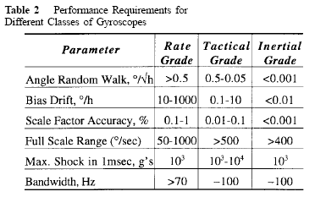
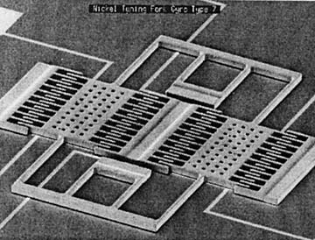
Vibrating-Wheel Gyroscopes have a wheel that is driven to vibrate about its axis of symmetry, and rotation about either in-plane axis results in the wheel’s tilting, a change that can be detected with capacitive electrodes under the wheel, Figure 3. It is possible to sense two axes of rotation with a single vibrating wheel. A surface micromachined polysilicon vibrating wheel gyro, Figure 4, has been designed at the U.C. Berkeley Sensors and Actuators Center that demonstrated this capability.
Table 1; Performance requirement for different type of gyroscopes
Figure 2 - The first working prototype of the Draper Lab comb drive tuning fork
 | 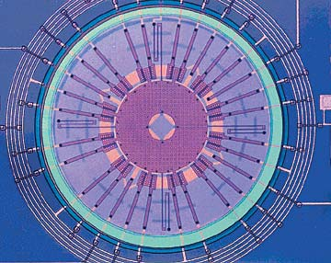
Figure 3 – Schematic design concept for Robert Bosch vibrating wheel. This design provides X/Y-axis sensing capability, and is being produce in production using poly silicon fabrication | Figure 4. This polysilicon surface-micromachined vibrating wheel gyro was designed at the Berkeley Sensors and Actuators Center.
Wine Glass Resonator Gyroscopes. A third type of gyro is the wine glass resonator. Fabricated from fused silica, this device is also known as a hemispherical resonant gyro. Researchers at the University of Michigan have fabricated resonant-ring gyros in planar form. In a wine glass gyro, the resonant ring is driven to resonance and the positions of the nodal points indicate the rotation angle. The input and output modes are nominally degenerate, but due to imperfect machining some tuning is required.
Challenges with Designing a MEMS Gyroscope
This section reviews some of the different choices that can be made for design of a vibrating gyroscope. Table 2 provides a summary of various design choices possible for a vibrating gyroscope, with over 2500 potential combinations. Most of research and development activities at the university level, with the University of California Berkeley being the most active, have been on surface micromachined gyros. One of the primary drivers for this has been DARPA and military interest for development of a single chip integrated six-axis inertial measurement units (IMU).
Gyroscopes are much more challenging sensor products than acceleration or pressure sensors. Gyroscopes are basically two high performing MEMS devices integrated into one single device that have to work together to produce results. They are a self-tuned resonator in the drive axis, and a micro-g sensor in the sensing axis. The absolute magnitude of the Coriolis force sensed is orders of magnitude lower than any high volume production MEMS accelerometer. Capacitive sensors are generally used for measuring these small changes of capacitance. Gyroscope performance is very sensitive to all potential manufacturing variations, packaging, linear acceleration, temperature, etc. To achieve high performance and lowcost, lots of care must be taken during the initial design. Gyroscope designers must achieve a solution that can be insensitive to most of these potential variations.
Application
Optical Gyro
Vibrating Gyro Gyro
Ring Laser Gyro
Design Style
Vibrating Mass
Vibrating Ring
Linear Vibration
Rotary Vibration
Z-axis Sensor
Single Mass
Dual Mass Tuning Fork
X/Y-axis Sensor
MEMS Technology
Poly Silicon
Bulk Silicon
Mixed Process
Actuation Mechanism
Parallel Plats
Piezoelectric
Electro-Magnetic
Electro-Static
Torsional Plates
Comb Drive
Coriolis Sensor
Electro-Static
Electro-Magnetic
Piezoelectric
Parallel Plats
Comb Fingers
Table 2: Shows the various options, >2500, that could be used for designing a gyroscope.

Gyroscope Packaging Challenges
One of the most difficult decisions that can have the biggest effect on the cost is the choice for the final package. Generally, packaging is one of the highest components of the final cost for most types of MEMS sensors. In majority of cases, sensor designers and MEMS experts are not packaging experts. MEMS designers are primarily focused on the design and development of the sensor element, with the objective of demonstrating performance on the bench. The task of taking the MEMS sensor element and package it is the packaging engineer’s problem. In order to have the lowest cost MEMS product packaging issues must be addressed up front in the initial phase of design cycle. MEMS by definition is a mechanical feature that can be manufactured in batch processing with little cost differential. It is very unlikely that a lowcost solution can be realized without addressing packaging issues properly on the outset.
Path to High-Performance and Low-Cost Gyroscopes
The main challenge for the MEMS gyroscope industry has been achieving high-performance and low-cost MEMS solutions. Although there are several high-performance MEMS gyroscopes in production already, they are still fairly costly for most applications. Today’s automotive gyroscopes cost more than $60 for more demanding applications like vehicle dynamic control, and navigation assist, and are slightly below than that for less demanding ones like roll-over detection. The automotive market has developed many safety and comfort related applications that relies on rate-sensors. Today they are only offered on the high-end cars, where cost is less of a concern. There are also many consumer applications that are waiting for smaller and more affordable gyroscopes, like input devices, camcorder stability control, and more. To benefit from all these high volume applications, a smaller size and lower cost gyroscopes are needed.
Figure 5; Shows automotive accelerometers price elasticity
A quick review of the price curve for MEMS accelerometers, figure 5, shows that high volume occurred once unit prices achieved $3 target prices. The initial manufacturers of these type of sensors, for the first few years were Lucas-Nova Sensors, and EG&G-IC-sensors. In spite of millions of dollars invested in automation, capacity build up, and quality control systems, they were only able to reduce their cost to just under $10, and could not meet market demand for $3. Analog, Motorola, and few other companies recognized the market needs and focused their development from the beginning on fabrication of low cost accelerometers. They succeeded in the design and development of a new generation of accelerometers products that broke the price barrier. This allowed the market for these products to reach its full potential. All the original companies that failed to recognize the need were forced out of the market and are no longer producing accelerometers.
There is a real market need for lowcost gyroscopes not unlike the accelerometers a decade ago. Once the cost targets are met this family of MEMS sensor will enjoy a drastic increase in volume and will become the next high-volume application for the MEMS industry.
Vibrating Gyroscope Production Status
This section provides some insight into the gyroscope designs, performance, and packaging of the top four vibrating gyroscope manufacturers worldwide, representing more than 95% of unit volumes shipped for this class of sensors.
Robert Bosch has been the most active in design and fabrication of silicon vibratory gyroscopes. They have 50% of the gyro market for the automotive VDC, and related applications today. They are producing in high volume, with several million units shipped already. Bosch has developed both Z axis and X./Y axis rate sensors. Its Z-axis design, shown in figure 6, was introduced in 1998 and uses electromagnetic drive with capacitive sensing. The X/Y-axis gyro is a rotary vibrating mass, which was briefly discussed earlier and the schematic of this design is shown in figure 3. The MEMS sensor element along with its custom ASIC and all the discrete component are packaged in a hermetically sealed metal can, figure 7 and 8 which is then place inside its automotive style plastic housing, figure 9, with integral connectors and mounting brackets.
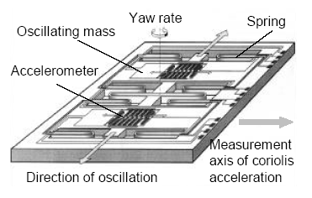 | 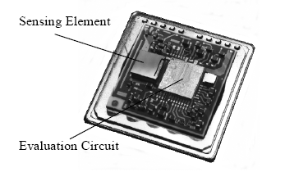
Figure 6; Bosch silicon dual mass tuning fork design, with Z-axis rate sense, in plan vibration and in plan sensing | Figure 7; Bosch MEMS sense element along with all supporting electronics, in a metal header package
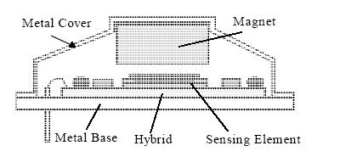 | 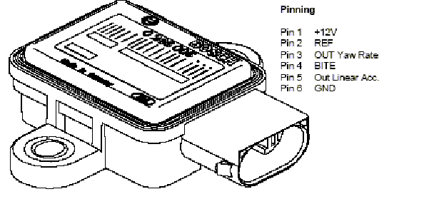
Figure 8; Bosch metal header cross section, showing the permanent magnet suspended over the sensor chip. | Figure 9; Bosch’s gyroscope package with integral connector and mounting brackets
BEI Systron Donner is a major manufacturer of rate sensors for automotive. Their gyroscope is designed based on using one-piece quartz inertial sensor, figure 10. These micromachined inertial sensing elements measure angular rotational velocity, using tuning fork vibratory principals and piezoelectric actuation and sensing. These sensors generate a signal output proportional to the rate of rotation sensed. Each sensor element is packaged in a hermetically sealed metal headers, figure 11, which are then combined with discrete electronic to produce the finished modules products, figure 12.
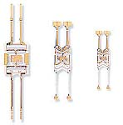 | 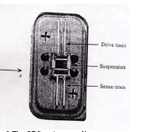 | 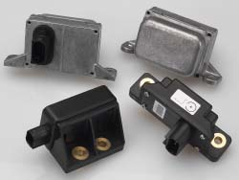
Figure 10; Systron Donner quartz sensing element
Figure 11; individual quartz elements are packaged in a metal header
Figure 12; Packaged sensor element are packaged with electronics for automotive
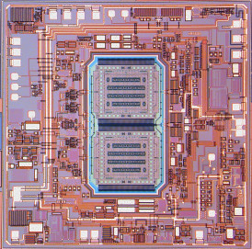
Figure 13. The iMEMS ADXRS angular rate-sensing gyro from Analog Devices
Silicon Sensing Systems a joint venture between Sumitomo and British Aerospace, has brought to market an electromagnetically driven and sensed MEMS gyro, figure 14, with a permanent magnet sits above the MEMS device, figure 15. Current passing through the conducting legs creates a force that resonates the ring. This Coriolis-induced ring motion is detected by induced voltages as the legs cut the magnetic field.
Analog Devices has been working on MEMS gyros for many years, and has patented several concepts based on modified tuning forks. The company has recently introduced the ADXRS family of integrated angular rate-sensing gyros, in which the mass is tethered to a polysilicon frame that allows it to resonate in only one direction. Capacitive silicon sensing elements interdigitated with stationary silicon beams attached to the substrate measure the Coriolis-induced displacement of the resonating mass and its frame, Figure 13.

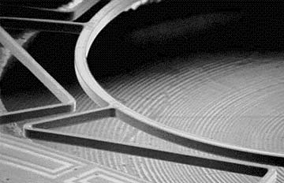 | 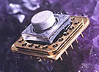 | 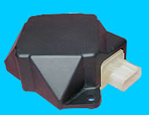
Figure 14. The resonant ring at the heart of the Silicon Sensing Systems gyro is shown here as an SEM image. Both electromagnetic drive and sensing are accomplished with a permanent magnet in the center (not shown). | Figure 15. Shows the Silicon Sensing Sensor package with a permanent magnet mounted directly on top of the sensor element in a metal can header for sealing under vacuum. | Figure 16. The Silicon Sensing Systems gyro. This device measures 29 by 29 by 18 mm and is used to stabilize the Segway Human Transport
Summary of State of Production; Table 3 shows a summary comparison of the key features for the top four manufactures of vibrating gyroscopes products representing greater than 95% of total volume being shipped presently.
Company | Rate Axis | MEMS | Drive | Sense | Package Type | Seal Ambient
Bosch | Z | Bulk | Electromagnetic | Capacitive | Metal header | Atmosphere
Bosch | X/Y | Polysilicon | Electrostatic | Capacitive | Metal header | Vacuum
BEI | Z | Quartz | Piezoelectric | Piezoelectric | Metal header | Atmosphere
Silicon Sensing | Z | Bulk | Electromagnetic | Electromagnetic | Metal header | Vacuum
ADI | Z | Poly | Electrostatic | Capacitive | Ceramic | Atmosphere
Table 3; Summary of various gyroscopes in volume production presently
Wafer-Scale-Integration and -Packaging
During the telecom bubble, optical MEMS took the spot light away from all other MEMS sensor developments including gyroscopes. Most MEMS sensor companies had pushed aside most of their sensor related development in favor of designing the next best optical components. MEMS mirrors were in the forefront of all these activities. With Nortel paying over 3.0 Billion dollars for Xros mirrors, it was logical for all MEMS companies and MEMS experts to move into the optical MEMS. Although, the telecom market did not materialize and most all MEMS optical companies are things of the past, venture capital firms and corporate telecom companies had invested billions of dollars in the MEMS industry. These investment dollars resulted in a more mature industry, with better infrastructure, more experts, and more advanced technologies. MEMS telecom companies were all trying hard to outperform their competition and be the first in the market with the most advance product. They generally were very protective of their IP and did not publish too many details on their design and development activities.
Silicon bulk micromachining has benefited the most from these investment dollars. Many companies focused their development efforts on building bulk silicon mirrors. Transparent Networks (TNI) was one such company. Started in 2000, TNI raised $30M dollars to develop high port count, 1000x1000, optical switch product base on bulk silicon. TNI had to develop many new technologies for its integrated single silicon chip with 1200 mirrors. One of these technologies was wafer-scale-integration, figure 18, where all the drive electronics were fabricated using a standard semiconductor foundry, and then they were integrated with the fabricated bulk silicon MEMS wafers. This enabled the fabrication of a 1200 integrated mirror arrays with four actuators each, figure 17, to be controlled with less than 120 connections and 2 watts of power. The key enabling technology was the mirror actuator mechanism called the “Nasiri-Platform.” One of the main design features of Nasiri-platform is its virtual-pivot and its ability to do angular amplification. While almost all MEMS mirrors where designed using dual gimbal design, by using the Nasiri-platform, TNI was able to drop the drive voltages from typically 400V to less than 120 volts, hence enabling electronic integration.
The TNI mirror design has many features that are similar to vibrating gyroscopes such as, mechanical actuators, sensing capacitance, and the need for integrated electronics. Bulk silicon micromachine industry had never seen this level of sophistication in its 30+ years of history.
Wafer-scale-packaging is another technology that has benefited from the optical boom. The most simple example of wafer-scale-packaging is addition of the protective cap over the active MEMS component that can provide the required sealing for further packaging and handling. Number of companies are already using this technology in production.
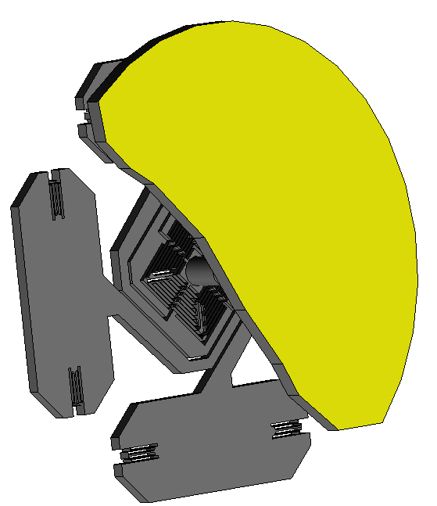 | 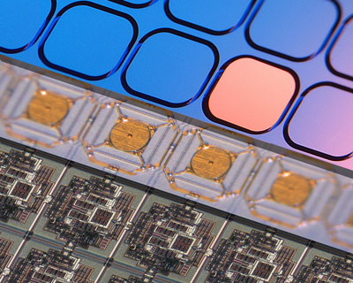
Figure 17; TNI mirror with Nasiri-Platform actuation | Figure 18; Vertical integration of the MEMS mirrors with drive electronics
Conclusion
Gyroscope is the next killer application for the MEMS sensor industry. There are many mature applications already developed and produce in limited volumes in automotive, consumer, industrial, medical, and the military market. Many high volume applications, in excess of 100 million per year, are waiting for the availability of a lowcost gyroscope. Today’s gyroscope products are not designed to address the growing cost demand, creating an opportunity for the new generation of gyroscopes. The new generation designs are primed to take advantage of all the latest development in the MEMS industry.
Bulk silicon can be a good lowcost solution for gyroscopes, due to its maturity and inherent higher mass, if the new design can eliminate the need for the use of magnets, metal can packaging, and allow for integrated electronics. Even more savings can be possible if standard off-the-shelf plastic packaging with lead frames can be utilized for the final assembly.
About the Author
Mr. Nasiri is a 26 years veteran in the MEMS industry with expertise in MEMS design, Fabrication and Packaging. Presently he is the President and CEO of InvenSense Inc. The company is working on the design and development of next generation vibrating gyroscopes with integrated electronics and wafer-scale-packaging to achieve the lowest possible cost for MEMS resonating gyroscopes.
Mr. Nasiri has been the cofounder and early stage executive in several successful Silicon Valley MEMS startup companies, where he had served as the VP of Operations and Engineering, including Honeywell-Sensym, GE-NovaSensor, Integrated Sensor Solutions, IMST (bought by Maxim), and most recently Transparent Networks, where he was the founder and Vice President of MEMS and Packaging.
Mr Nasiri was the main driver and the managing director for the successful ISS-Nagano Gmbh (bought by Texas Instrument) startup in Germany, where he designed and developed his novel high-pressure sensor packages for under-the-hood automotive applications. These products and products based on his concept are being manufactured worldwide in of tens of million units annually.
Mr. Nasiri has an MBA from Santa Clara University, and an MSME from San Jose State University, and BSME from University of California Berkeley. He has 10 patents issued and over 12 pending.
References
- N. Yazdi, F. Ayazi, and K. Najafi. Aug. 1998. “Micromachined Inertial Sensors,” Proc IEEE, Vol. 86, No. 8.
- Jonathan Bernstein, Corning-IntelliSense Corp , MEMS inertial sensing technology
- S.Nasiri, Wafer Level Packaging of MOEMS Solves Manufacturability Challenges In Optical Cross Connect, 2003,
- S.Nasiri patent, MEMS Mirrors and MEMS arrays, Pat# 6,480,320
- T.B. Gabrielson. May 1993. “Mechanical-thermal noise in micromachined acoustic and vibration sensors,” IEEE Trans, Electron. Devices, Vol. 40:903-909.
- J. Bernstein et al. 8 June 1998. “Low Noise MEMS Vibration Sensor for Geophysical Applications,” Proc 1998 Solid State Sensor and Actuator Workshop, Hilton Head Island, SC:55-58. Extended version also in IEEE JMEMS Dec. 1999.
- M. Lutz et al. June 1997. “A precision yaw rate sensor in sillicon micromachining,” Tech Dig 9th Intl. Conf Solid State Sensors and Actuators (Transducers ’97), Chicago, IL:847-850.
- Y. Gianchandani and K. Najafi. June 1992. “A bulk silicon dissolved wafer process for microelectromechanical systems,” J Microelectromech Syst:77-85.
- J. Bernstein et al. Feb. 1993. “A micromachined comb-drive tuning fork rate gyroscope,” Proc IEEE Micro Electro Mechanical Systems Workshop (MEMS ’93), Fort Lauderdale, FL:143-148.
- J.J. Bernstein and M.S. Weinberg. 5 March 1996. U.S. Patent #5,496,436, “Comb-Drive Micromechanical Tuning Fork Gyro Fabrication Method.”

