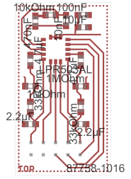

Pinlist

Exported from test_LPR503AL.brd at 03-03-2010 13:41:50

EAGLE Version 5.7.0 Copyright (c) 1988-2010 CadSoft

Part Pad Net

IC1 1 GND
10 N$4
11 ST
12 PD
13 HP
14 VDD
15 VDD
16 VDD
2 N$13
3 N$15
4 N$1
5 OUTY
6 4XOUTY
7 VREF
8 4XOUTX
9 OUTX

CON 1 VDD
10 OUTX
2 OUTY
3 GND
4 4XOUTY
5 HP
6 VREF
7 PD
8 4XOUTX
9 ST

