MAXBOTIX SENSORS
Maxbotix is offering the EZ0, EZ1, EZ2, EZ3, and EZ4 with progressively narrower beam angles allowing the sensor to match the application.
How can I get the best possible accuracy from the analog voltage output?
First, many users have reported that this is the interface of choice for them. In addition, from these users we have heard that the analog voltage output agrees with the other outputs. This is true for most users because the MaxSonar®-EZ1™ sets this voltage to within 5 mV, twice the accuracy required.
But if in your application the MaxSonar®-EZ1™ analog voltage output has noise, there is an easy way to remove the noise on the analog voltage output. Place a 0.1uF capacitor near/at your analog to digital pin directly to your ground. Next place a 10K ohm resistor in series with the analog voltage output from the MaxSonar®-EZ1™ to the 0.1uF capacitor. The time constant for this circuit will be 1mS. This will cause a 5mS delay to allow the voltage to settle. For slower readings and slightly less noise the resistor can be increased to 100K ohms and this will cause a 50mS delay. (If you are technical please read the sections following this answer for the reasons why this might be needed.)
Electrical noise
When electrical noise is introduced on the line, it can cause the MaxSonar sensors to output unstable readings. Known items that cause excessive power supply noise are Sharp infrared range sensors, XBee radios, some wireless control systems, some switching power supplies, some servos, etc.
There is a simple solution that eliminates the effects of a dirty power supply to the sensor. By placing a resistor in series with the V+, along with a 100uF capacitor (Digi-Key part number: P803-ND or equivalent) to ground, you create an effective filter (i.e. almost a placebo battery) for the sensor. This ensures that almost any noise introduced onto the line is captured and only clean stable power is supplied to the sensor. For the circuit connections please see the schematic below:
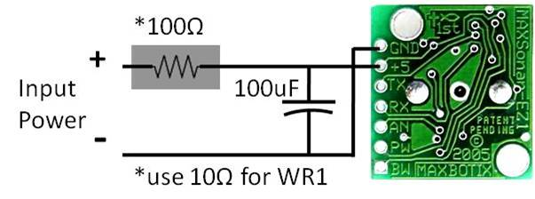

Multiple Sensors
The first and most obvious cause of unstable readings is interference when running multiple sensors. These can in general be easily determined and corrected. When running more than one sensor they should be pointed in different directions or they should be ran at different times.
-Free Run All Sensors (not recommended)

-Sequentially Read Each Sensor (always works):
Only start one device every 50mS. This allows each device to range only after the previous has finished. This method will always work. There will not be any interference between sensors, but ranging frequency drops by the factor of "the number of sensors used". Please see question 6f for additional information.
-Alternatives:
Daisy Chaining using a Commanded Loop
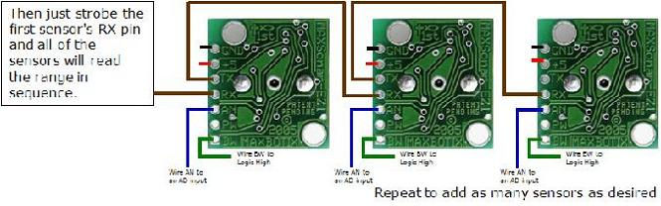Figure 6.5.
To chain the sensors, and have them operate in sequential daisy-chained fashion, you do so by linking the TX of unit 1 to RX of unit 2 and so on. The BW pin is tied high on all of the parts. Then just strobe the first sensor's RX pin and all of the sensors will read the range in sequence. The analog values can then be read. The example in Figure 6.5 would use one pin to command the chain, and three analog to digital inputs. Please click the link to the download the PDF file.Commanded Loop PDF File

Daisy Chaining with Constantly Looping
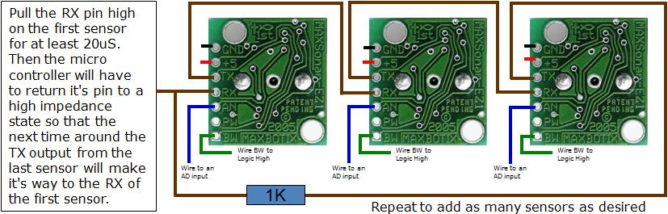Figure 6.6.
If you want them to keep running and constantly loop and always provide the latest range reading you will have to do two things.
First, add a resistor between the last sensor's TX back to the Rx of the first unit through a 1K resistor as shown in Figure 6.6.
Second, you will have to "kick start" them, (at least 250mS or more after power is applied to the sensors to give the sensors this time to boot-up). To do this, pull the RX pin high on the first sensor for at least 20uS. Then controller will have to return it's pin to a high impedance state so that the next time around the TX output from the last sensor will make it's way to the RX of the first sensor. Then all of the sensors in the chain will run in sequence. This "ring of sensors" will cycle around and around, constantly maintaining the validity of their analog values. You can then read the latest range reading (i.e. the analog value) at any time. This is the easiest way to use them.
After pulling the RX pin low, you can read the analog pin about 50mS (100mS if this is the first time reading the sensor as it calibrates upon the first commanded range cycle after power up, i.e. the sensor must complete a range cycle). In addition, the most recent range reading is always ready to be read on the analog voltage pin, so once you start the chain, and if you are using it in continuous mode, you can read the values at any time. Please click the link to download the PDF file. Constantly Looping PDF File

Simultaneous Operation
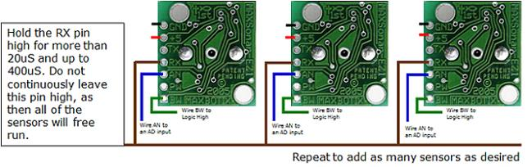Figure 6.7.
You can also run them all at the same time (and for some uses this is preferred as the measurement speed is maximum, but it is only for selected applications). Just tie all of the RX pins together and command them with a pin from your microcontroller as shown in figure 6.7. Hold the pin high for more than 20uS. Do not continuously leave this pin high, as then all of the sensors will free run as described above. Command the sensors every 50mS or whenever a new range reading is desired. Please click the link to download the PDF file. Simultaneous Operation PDF File

Might be of some interest:
http://www.maxbotix.com/MaxSonar-EZ1__FAQ.html#How_does_the_signal_system_in_the_MaxSonar_EZ1_work
http://produto.mercadolivre.com.br/MLB-108328217-maxsonar-ez2-max-sonar-ez-2-maxsonar-ez2-_JM
http://www.rgbled.org/maxbotix/index.html
http://www.cocoontech.com/forums/index.php?showtopic=4419
http://www.cocoontech.com/forums/index.php?showtopic=4666
http://screwdecaf.cx/high-lighter.html

