RODAS
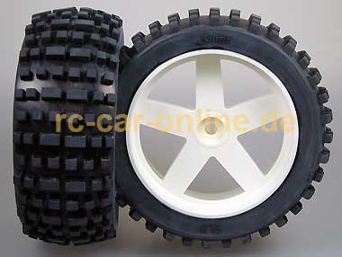
1/6 offroad tire, mounted and glued on rims to fit FG and Carson/Firehammer cars. Diameter 165 mm, width 65 mm, 18 mm wheel square.
http://www.rc-car-online-shop.de/lshop,showdetail,4487,e,1275564030-13269,reifen.reifen_angebot,y0199,,Tshowrub--reifen.reifen_angebot,.htm

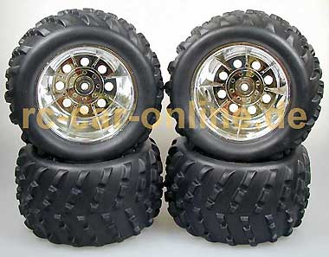
Tires mounted and glued on rims, set of four.
Durchmesser x Breite / diameter x width 190 x 110 mm
Rim with 18 mm square drive
http://www.rc-car-online-shop.de/lshop,showdetail,4487,e,1275564030-13269,reifen.reifen_angebot,offroad_0001,,Tshowrub--reifen.reifen_angebot,.htm

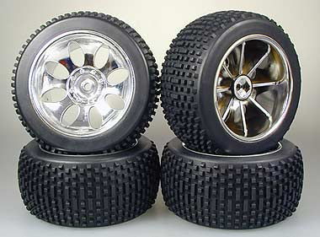
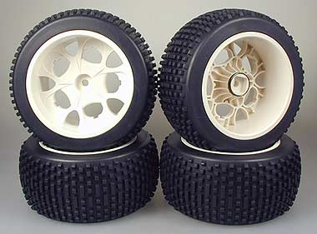
Complete set of four CRT stadium tires and rims, mounted and glued with tire inserts. Fits FG and Carson 1/6 scale cars without modifications.
Tire diameter 170 mm, tire width 80 mm, 18 mm wheel square.
The white rims are compatible with wheel-mounted disc brakes, the chrome ones are not!
http://www.rc-car-online-shop.de/lshop,showdetail,4487,e,1275564030-13269,reifen.reifen_angebot,y0361,,Tshowrub--reifen.reifen_angebot,.htm
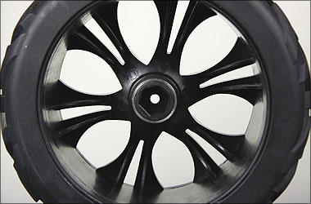
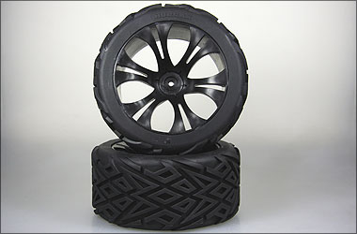

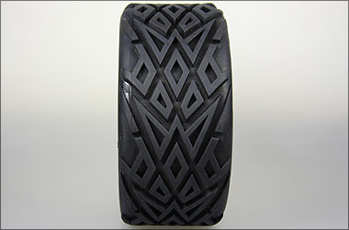

Outer diameter 206 mm
Width 93 mm
17 mm hex wheel drive
http://www.rc-car-online-shop.de/cgi-bin/cosmoshop/lshop.cgi?action=showdetail&wkid=4487&ls=e&nc=1275564545-16504&rubnum=&artnum=HX0051B&file=&gesamt_zeilen=0Tsuche--150%20mm
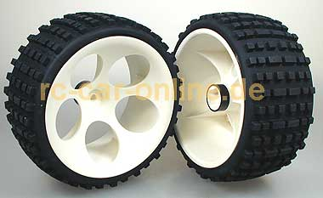

Wide Baja Buggy tires 80mm, ready glued on rims. Suitable for all 1:6 Off-Road Buggies. To mount them on FG Off-Road models you need the 14mm square wheel driver 6106/01.
Durchmesser x Breite / diameter x width 180 x 75 mm

http://www.rc-car-online-shop.de/cgi-bin/cosmoshop/lshop.cgi?action=showdetail&wkid=2646&ls=e&nc=1275662297-3565&rubnum=&artnum=fg_60209_05&file=&gesamt_zeilen=0Tsuche--180%20mm

