Instalation procedure for the Ricoh Aficio 2045 PLC 5e printer

The printer is located in DEM's secretary. This procedure explains how to install the Ricoh Aficio 2045 PLC 5e in Windows XP.
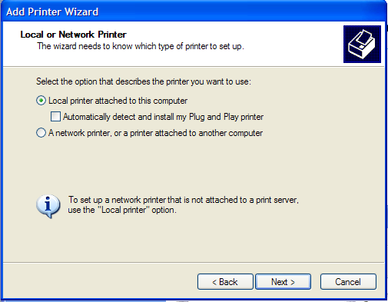
Figure 1
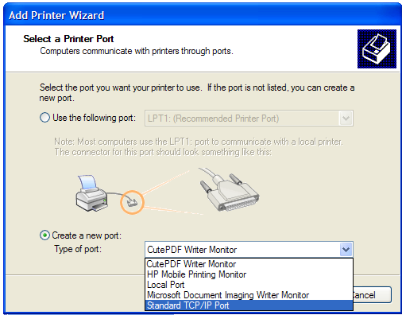
Figure 2
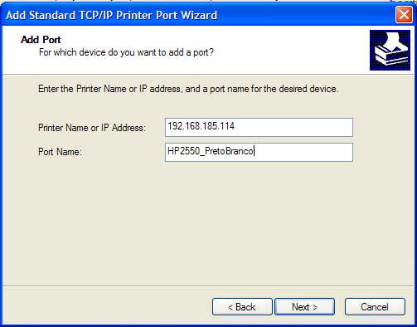
Figure 3
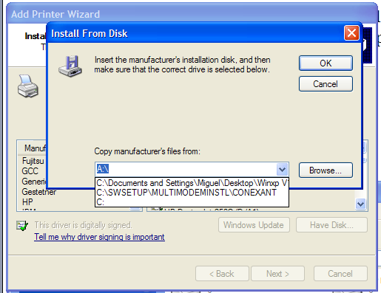
Figure 4

- Go to the control pannel and select printers and faxes.
- Chose the option add new printer.
- Select the option local printer, without activating the autodetect checkbox, see Figure 1.
- Create a new port, type Standard TCP/IP Port, Figure 2.
- Insert IP adress 193.137.85.169, filling name as, for example, Ricoh_DEM, Figure 3
- Afterwards the printers' drivers are required (download at http://www.ricohusa.com/downloads/downloads.asptsn=RicohUSA&path=http://support.ricoh.com/bb/html/ dr_ut_e/rc2/model/x2035e_45e/x2035e_45een.htm).
- Unzip the drivers to a temporary folder.
- Choose the option disk and select the directory to where the drivers have been unziped, Figure 4.

